Walkthrough for The Winning 11 app

Our App best works on an iPhone 11 pro max device.

The app has a login and signup feature to start. Make sure you give the correct credentials in the login to enter as bad credentials are restricted by the app.

The signup has validation in place and you cannot enter with incorrect data or the data that is already used. The password has validations in place and it only accepts if the password has

* At least one capital letter
* At least one small letter
* At least one number
* The password should be at least a length of 8.

We have created a demo id for you if needed.

Username: [priyankab407@gmail.com](mailto:priyankab407@gmail.com)

password: Tata@100

The screens look as below: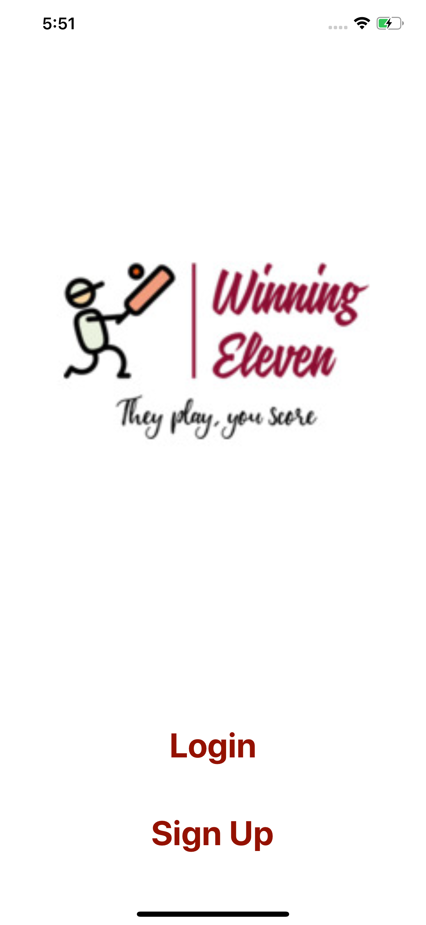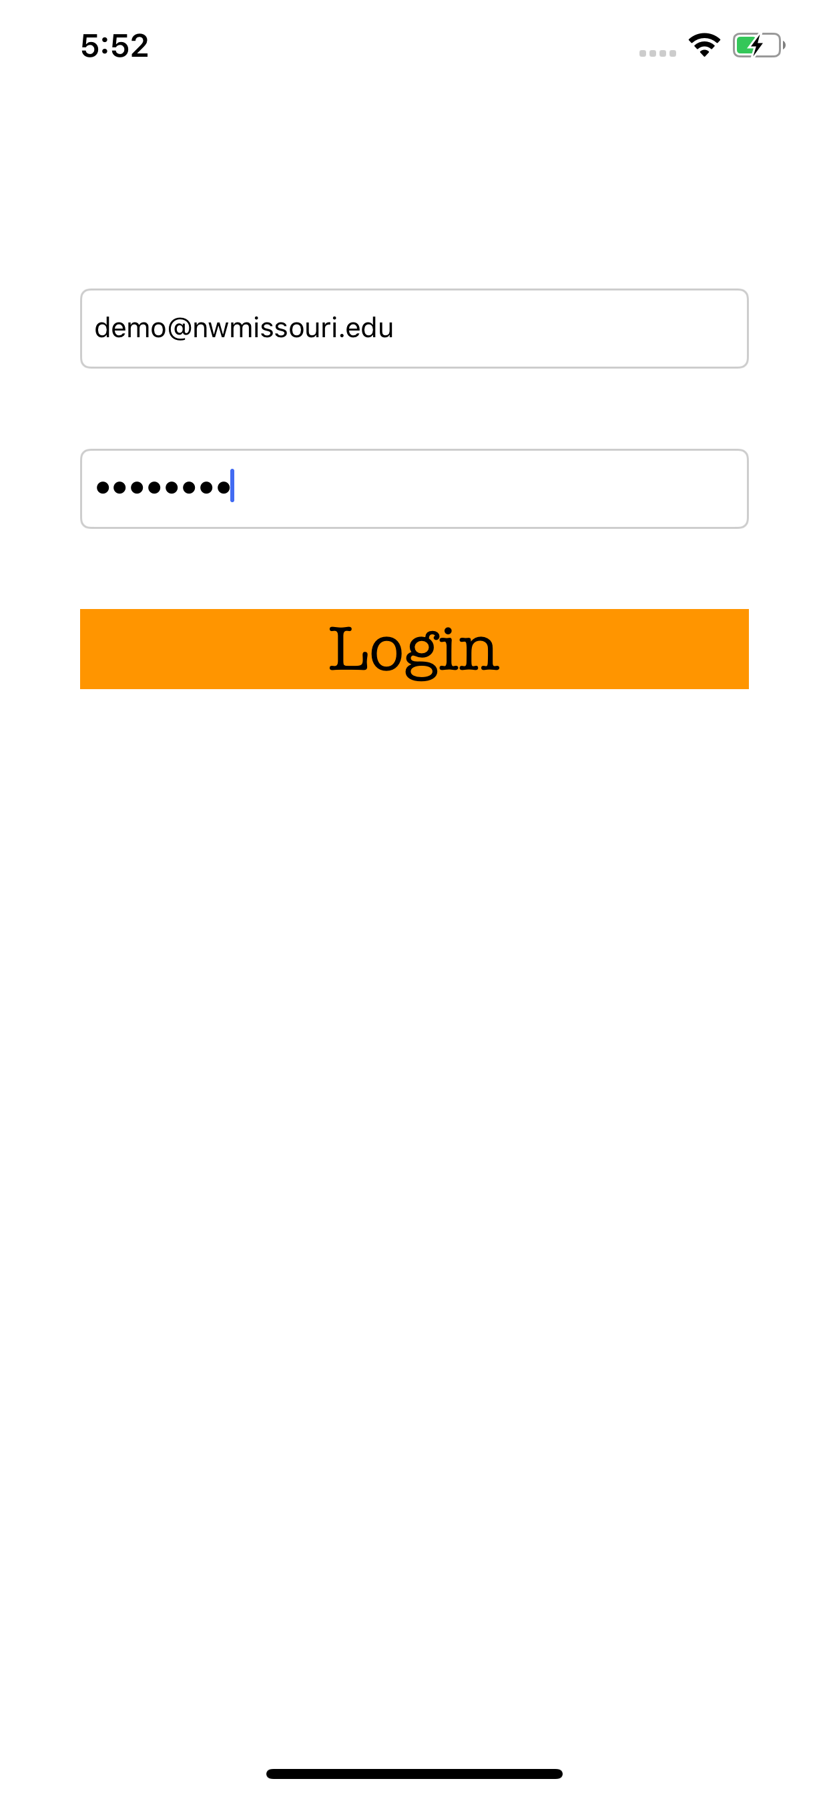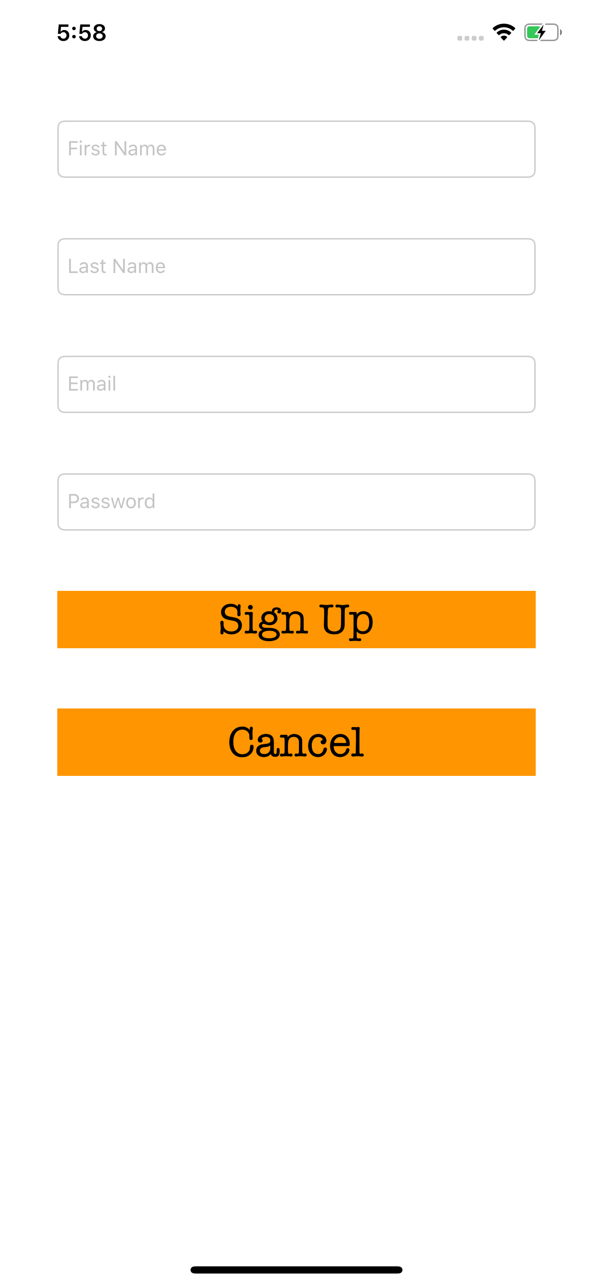

When the user is successfully logged to the app, they will be presented with the matches that are available and they have to select any match of their choice.

Then the user needs to select the players for his team. There are restrictions for the number of players to be selected.

* Total players - 11
* Batsmen - 4
* Bowler - 4
* Allrounder - 2
* Wicket-keeper - 1

The user will be prompted with an error when any of the above numbers don’t match while creating a team.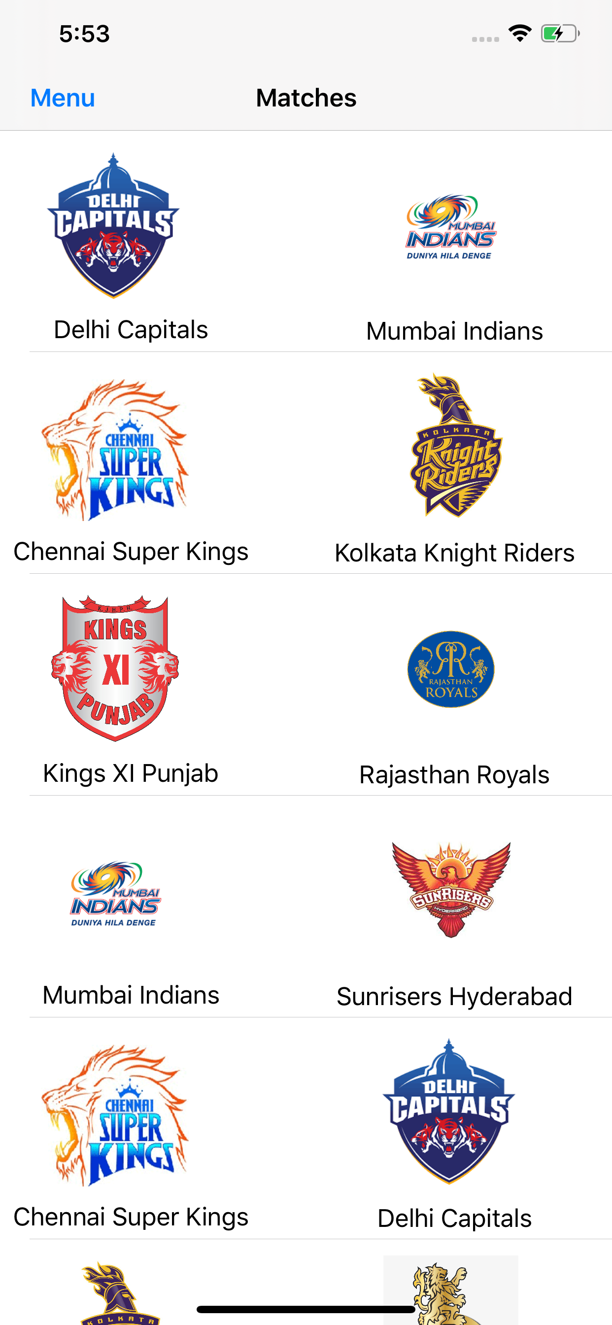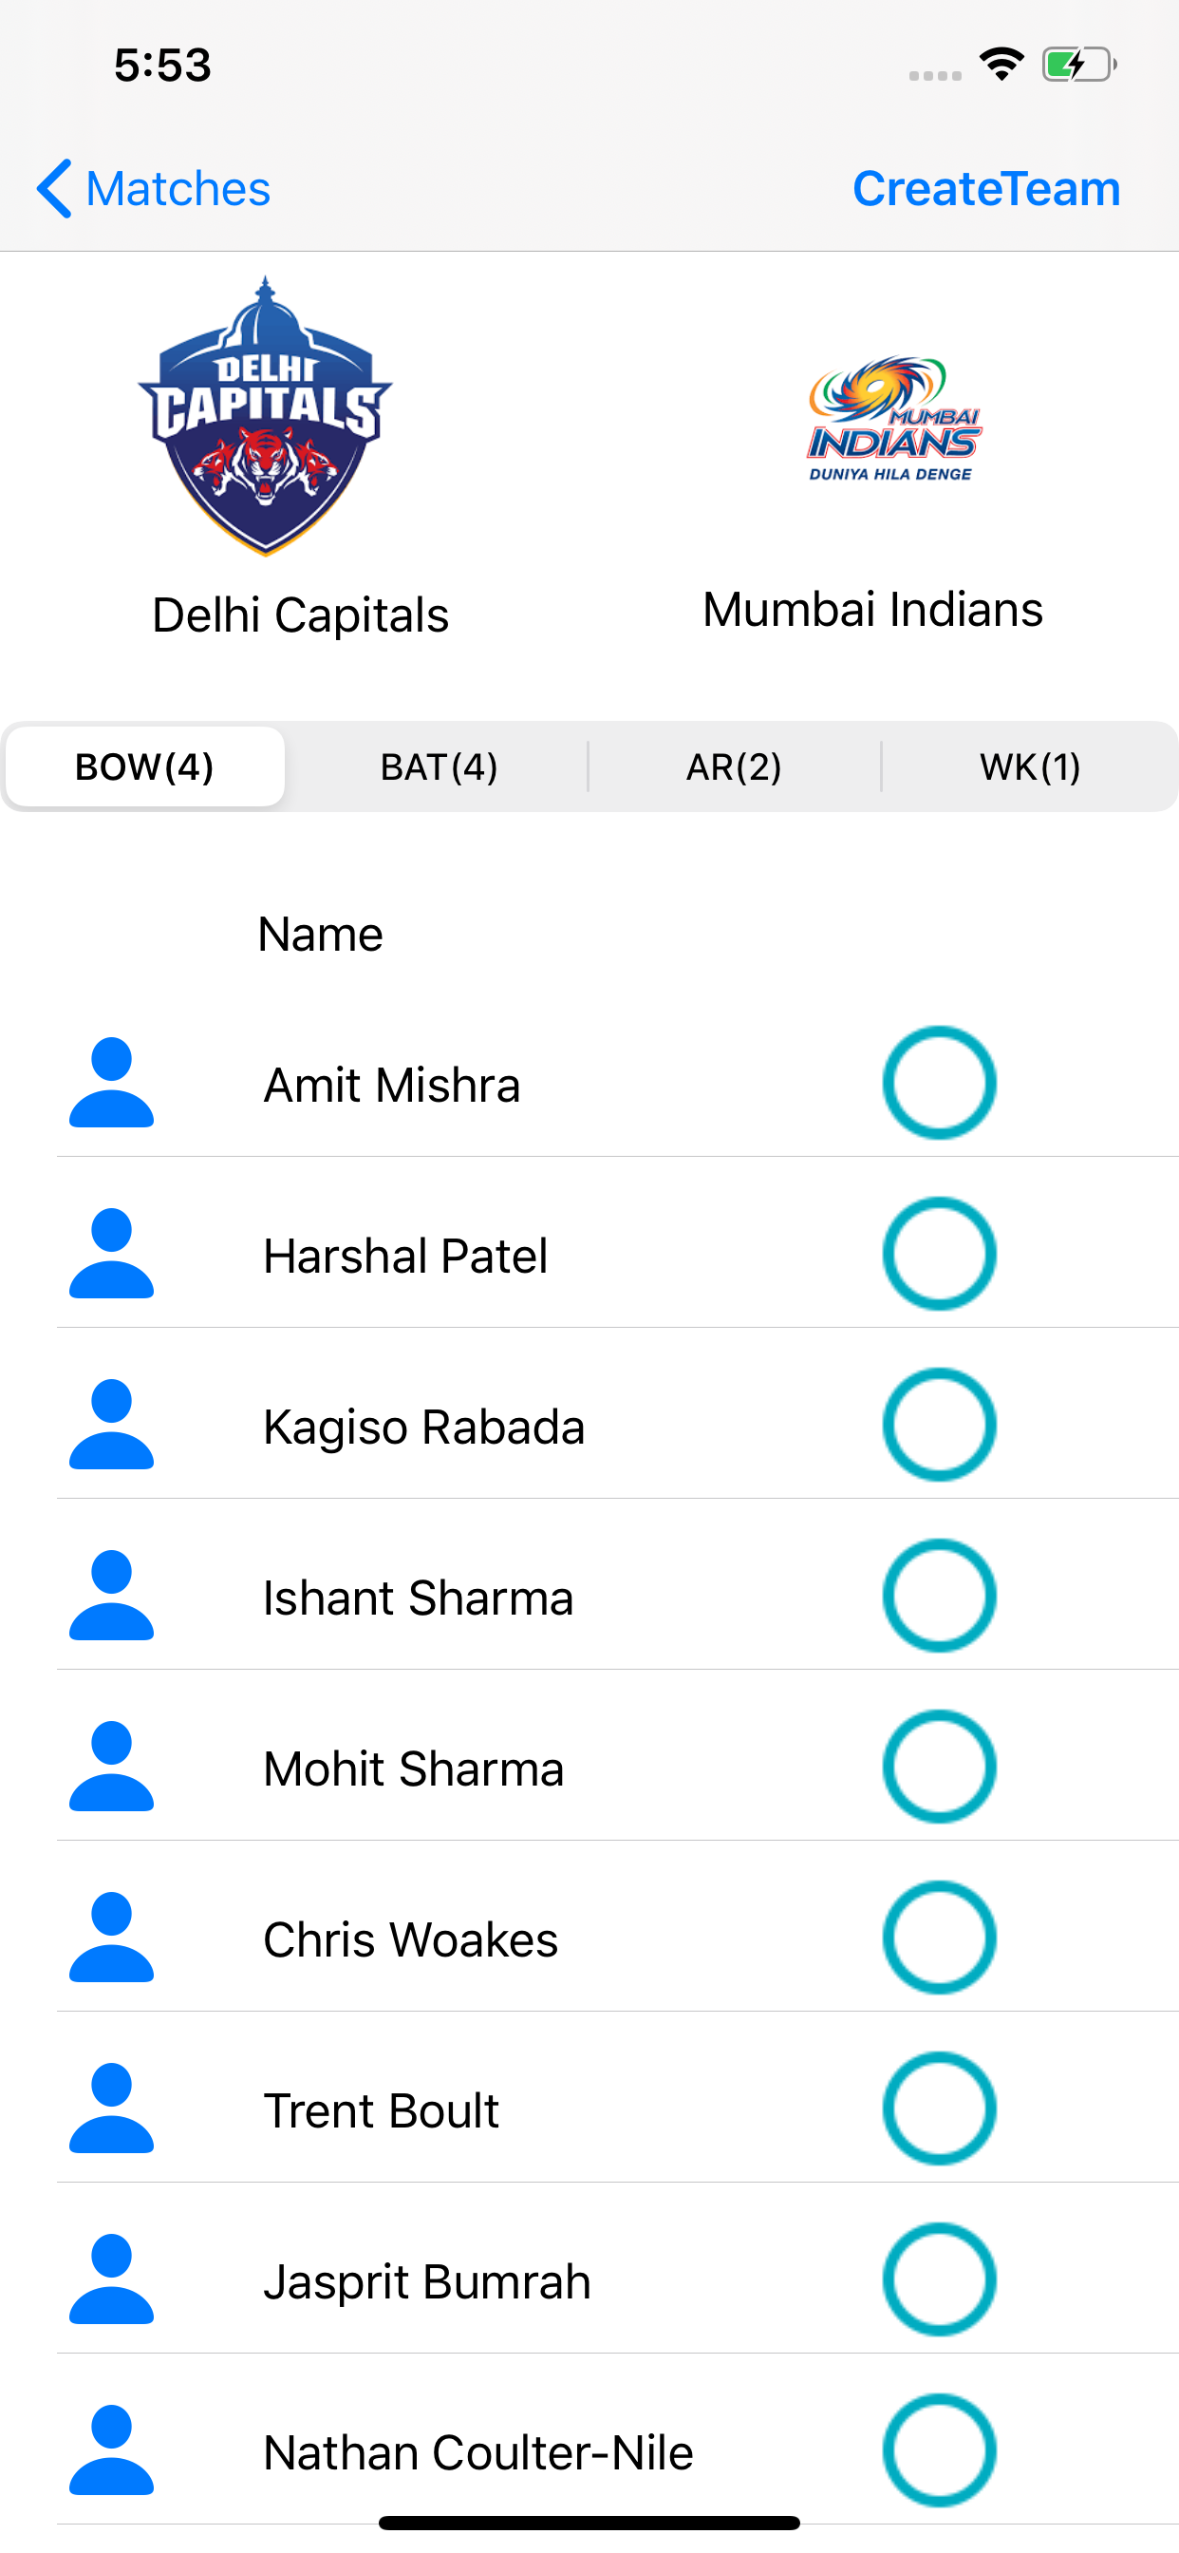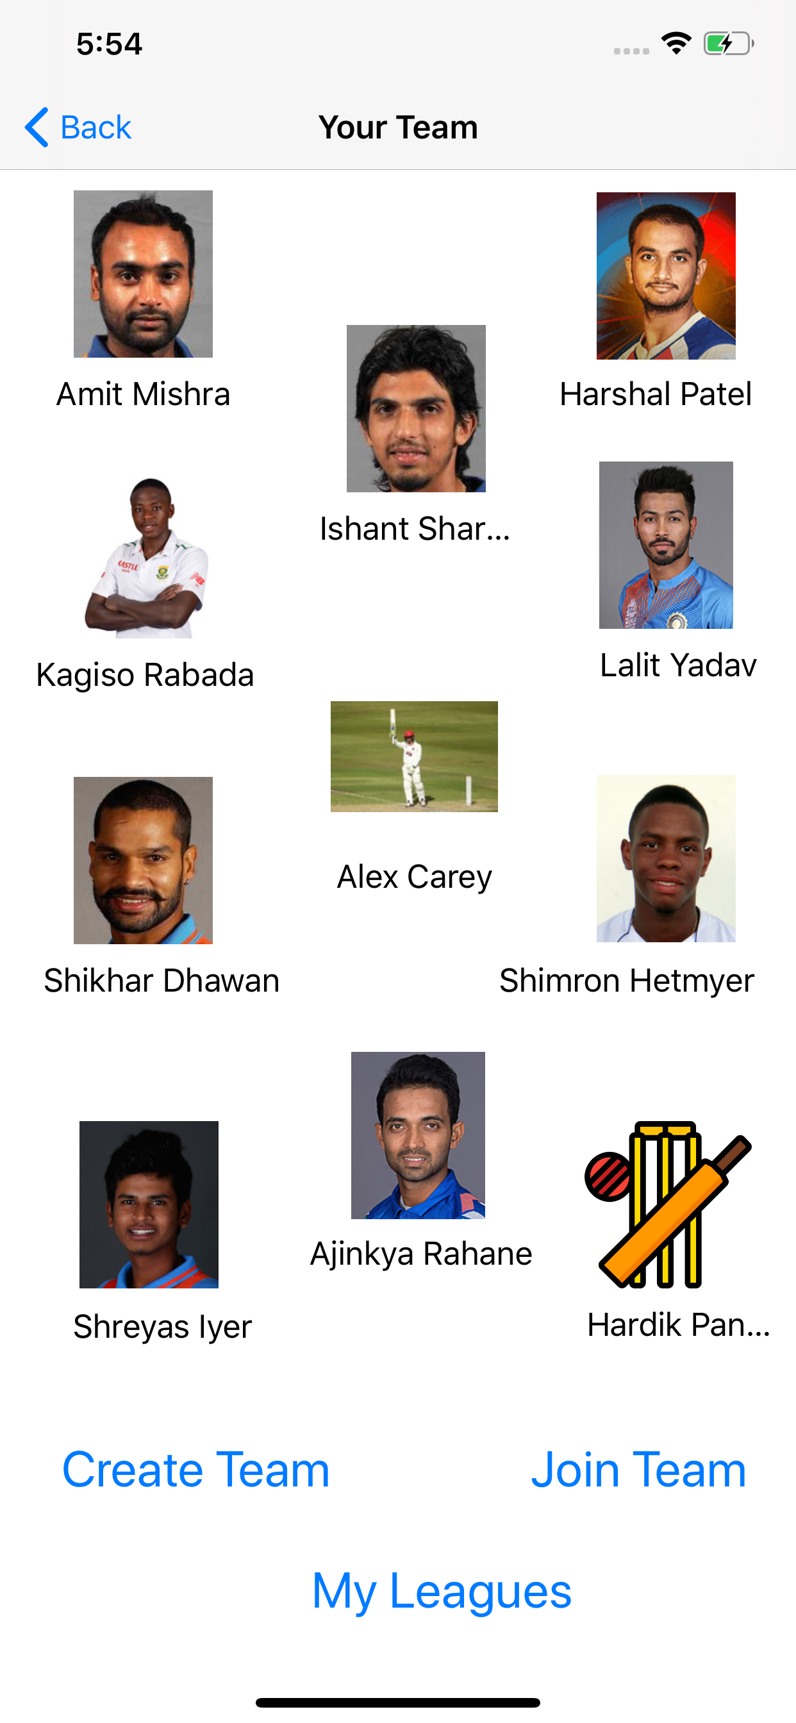

The user now has two options, create a team and Join team

The create team allows user to create a league and his team is saved into it. The Join team allows the user to join an already existing league provided they have the league code. The leagues view gives the leagues the user is part of.

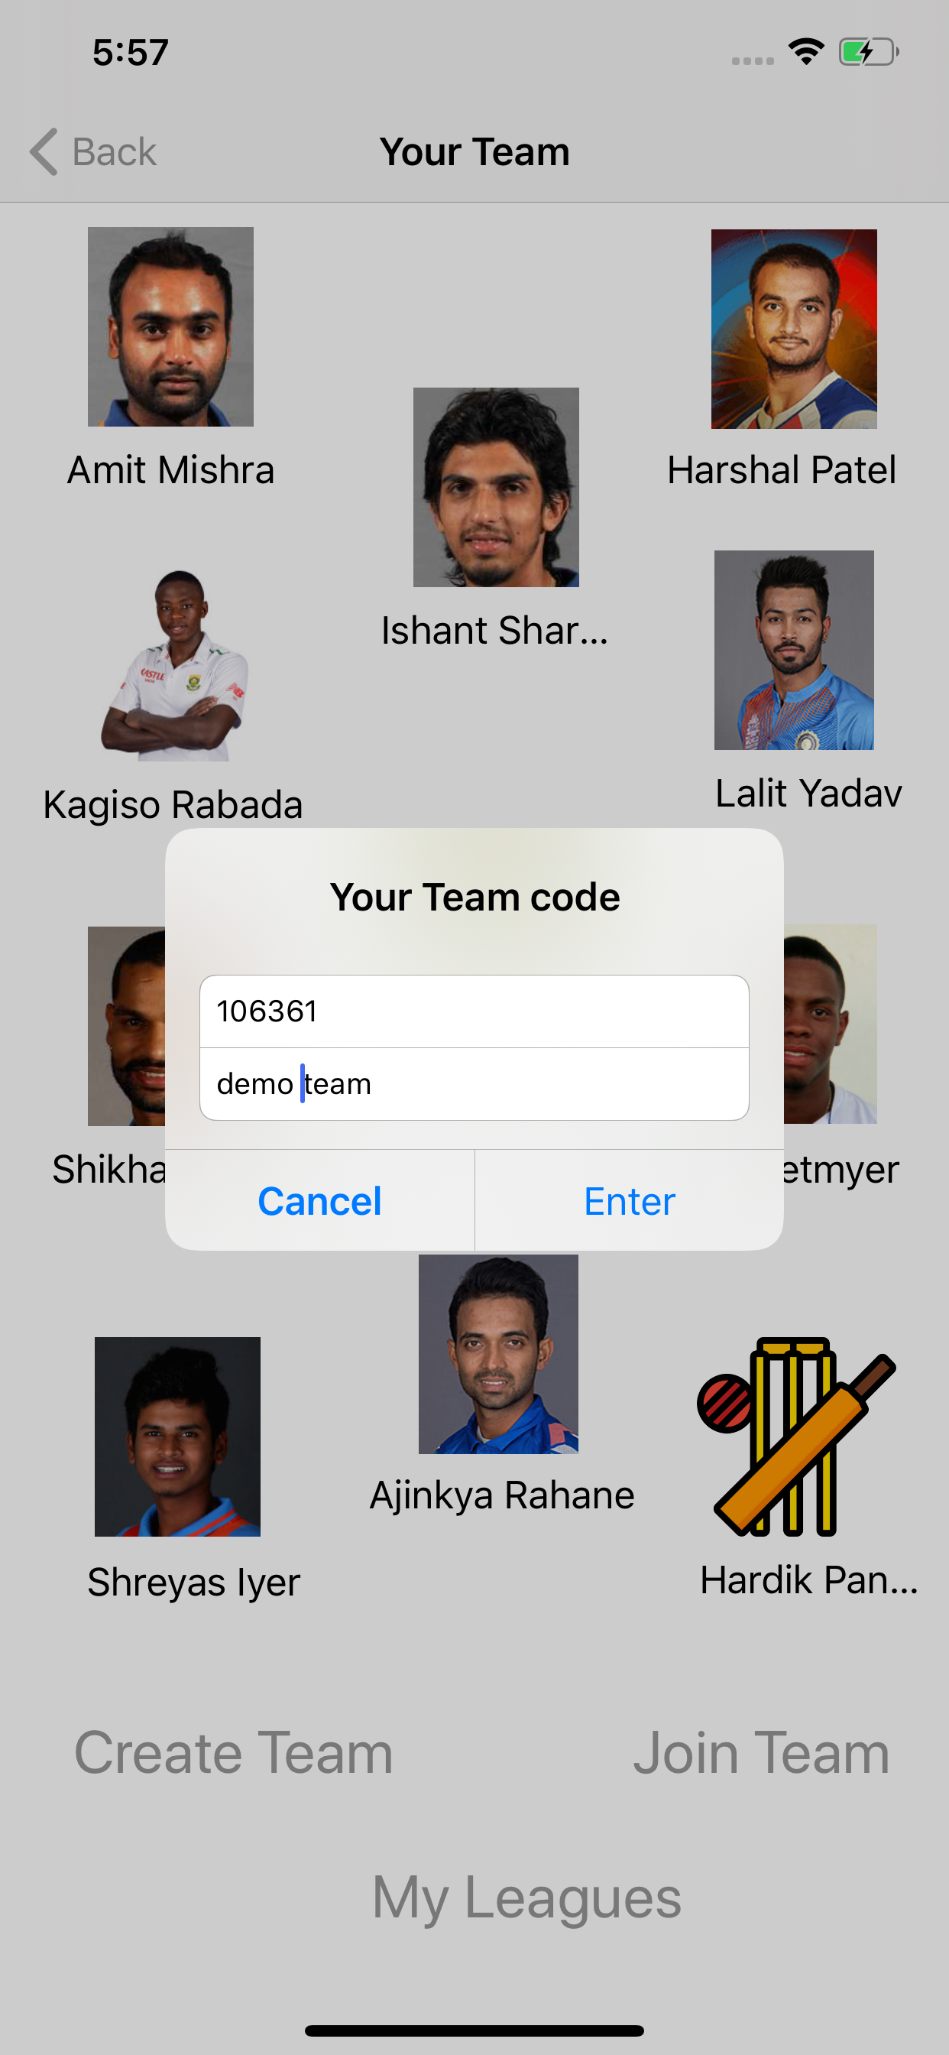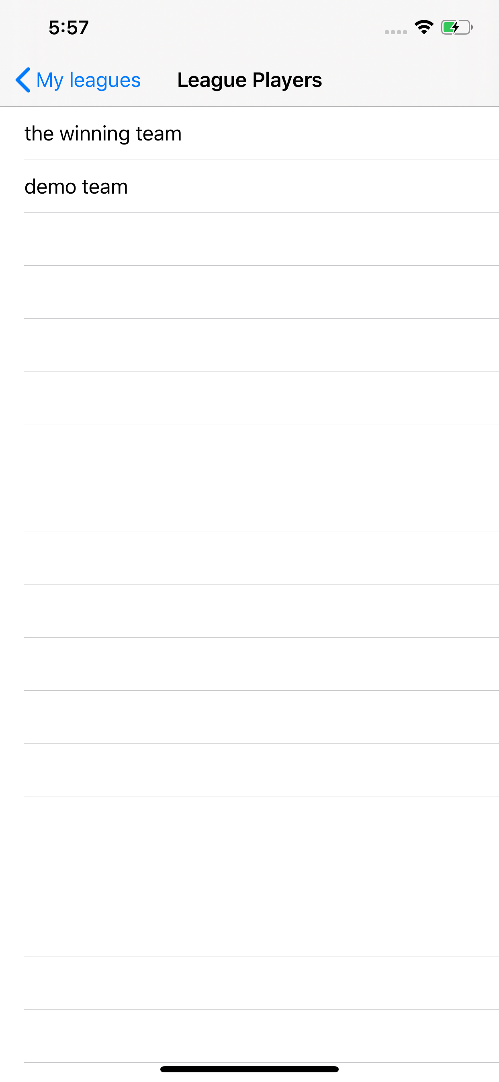

The user has a menu option in the matches view where there are options for Contact us, scoring system, and Logout.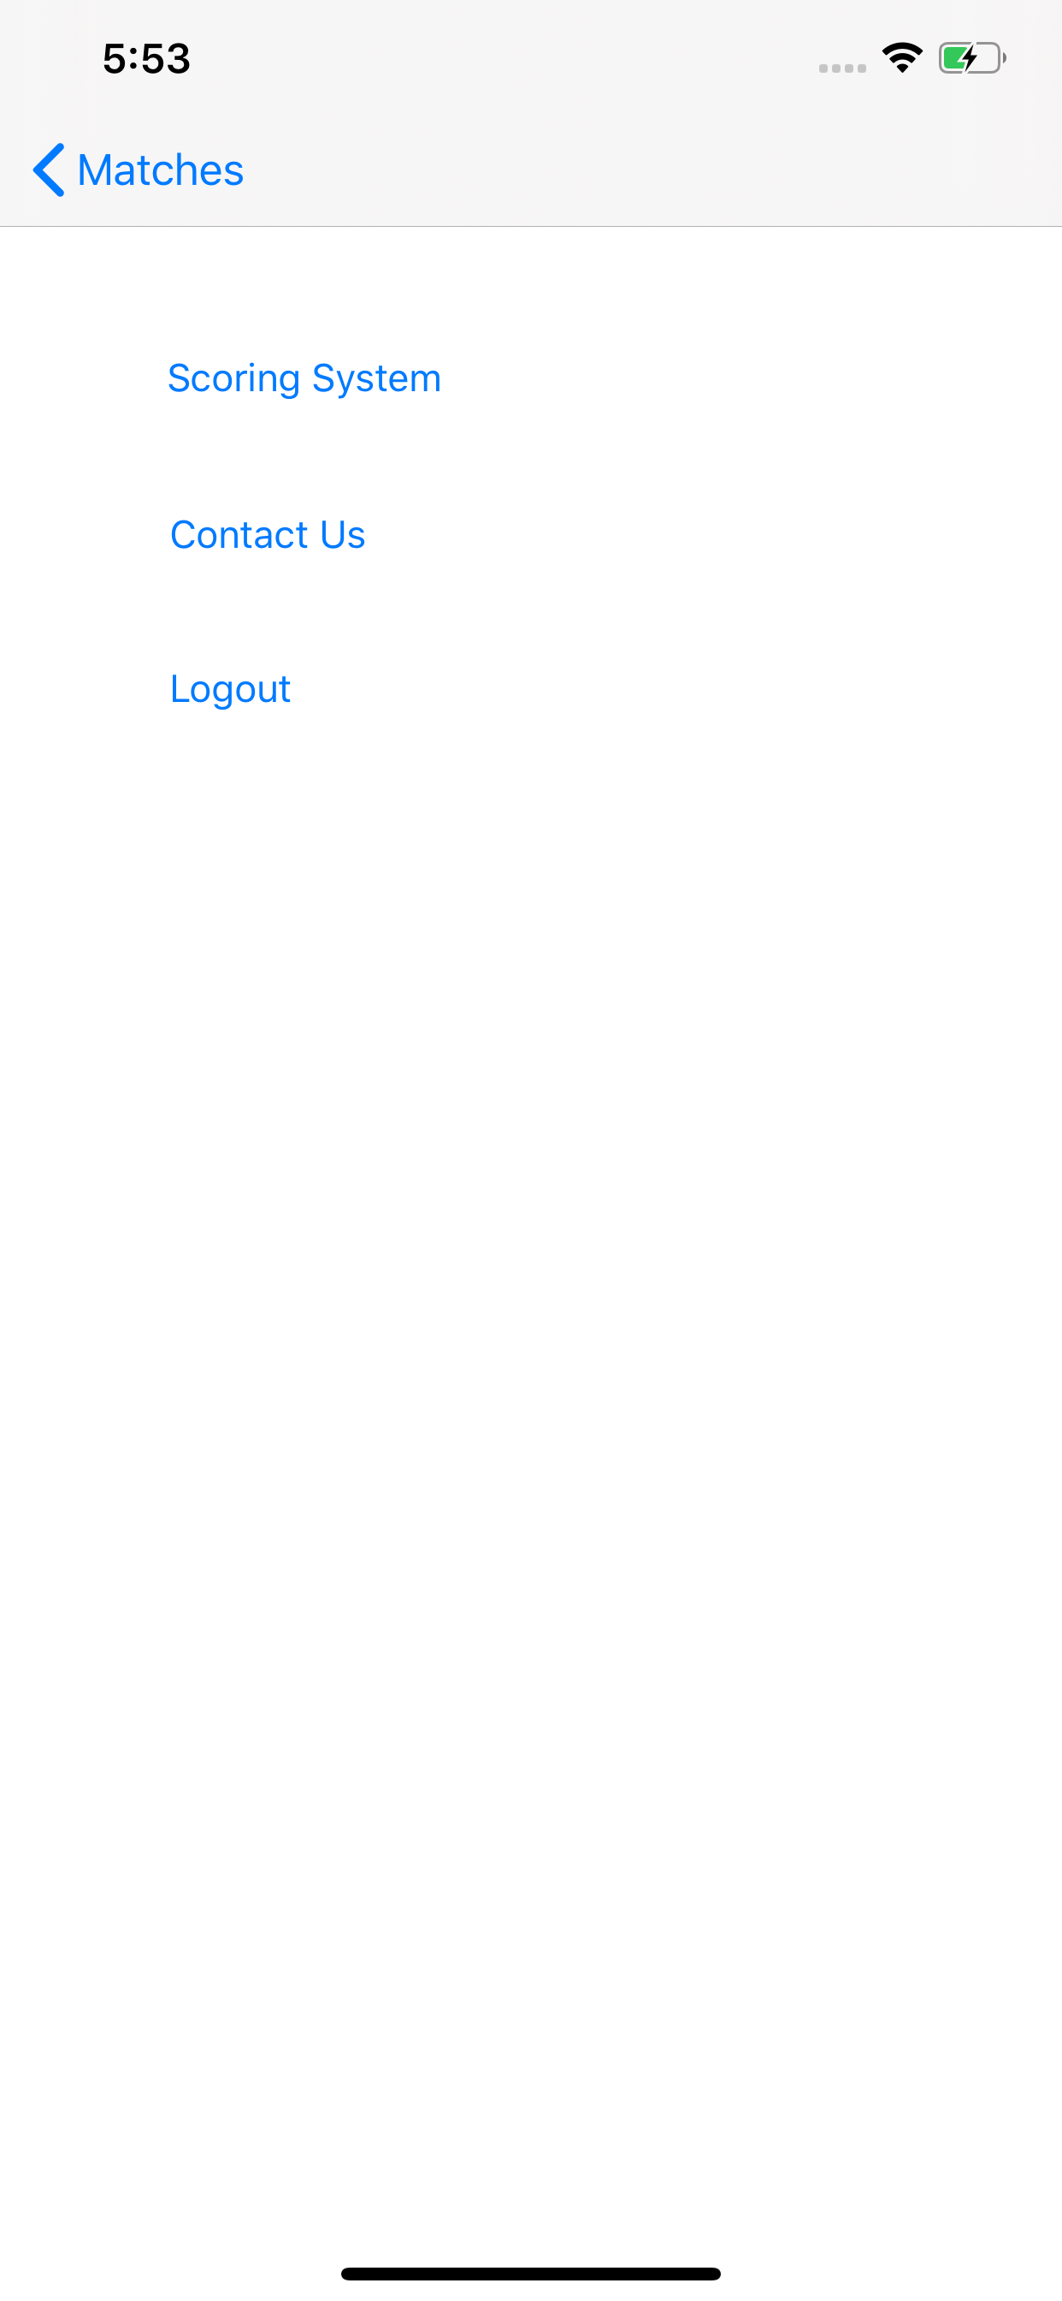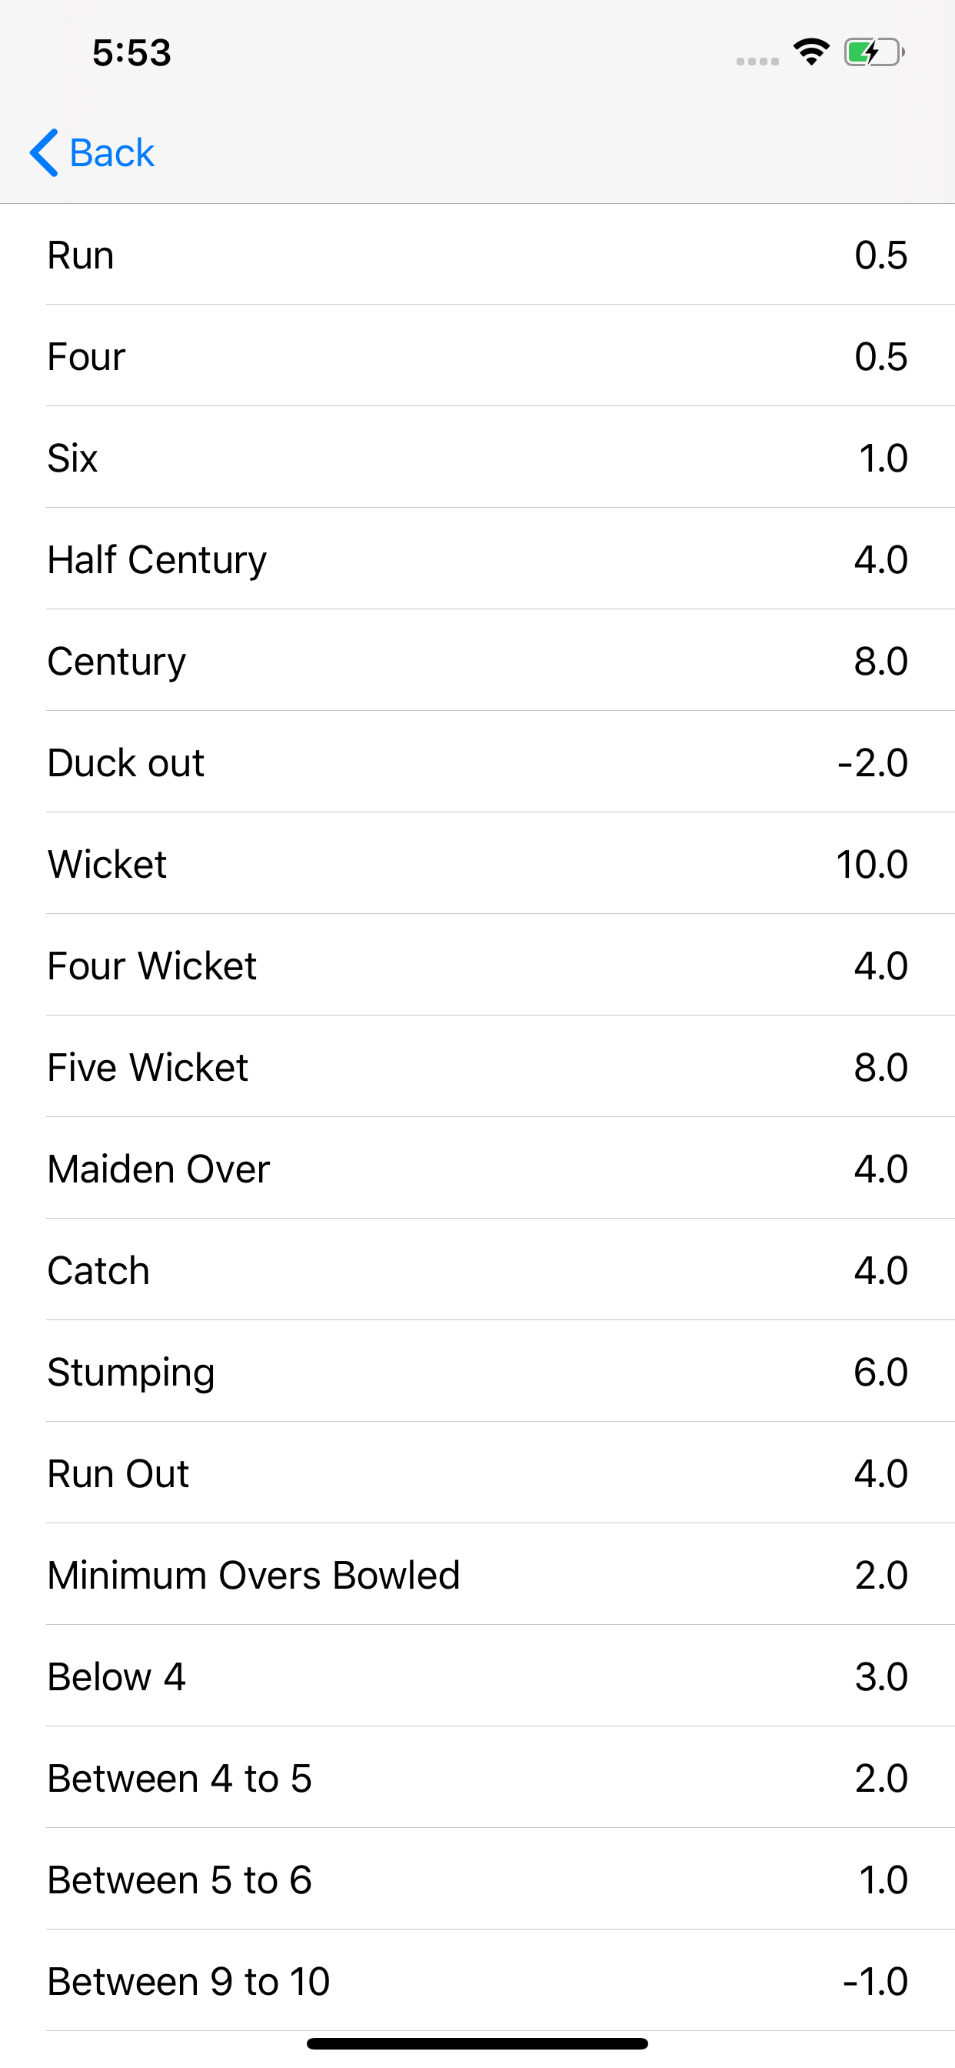

Future of the project: Because of the pandemic we are not able to implement the live score updations for the team as there are no matches that are happening and the api doesn’t return score details.